Day Trip to Adadi Maryam Rock Hewan Churches and Tiya Stelae Archeological Sites
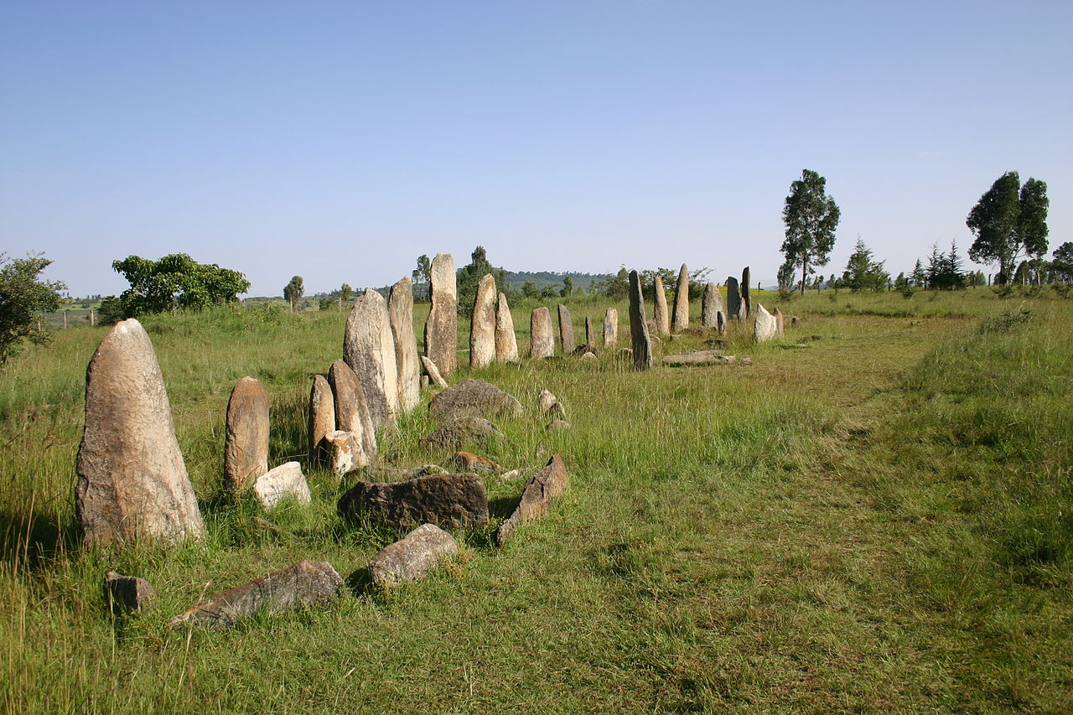
Duration-Full days
Mode of transportation: - Car

Tiya Stelae Archeological Sites
we will meet you at the airport or hotel then we will drive 88km to the south of Addis Ababa and our first stop will be Adadi Mariyam Rock hewen Church. It was built around the 12 th and 13th C and the history of the establishment of the church have a connection with ST Lalibela when he come to visit the scared mountain of Ziquala in the 12th c he built the church for the commemoration of st Mary’s then we will be beheading to UNESCO registered sites with among the most important of the roughly 160 archaeological sites discovered so far in the Soddo region, south of Addis Ababa. The site contains 42 monuments, including 32 carved stelae covered with symbols, most of which are difficult to decipher. They are the remains of an ancient Ethiopian culture whose age has not yet been precisely determined. then after having lunch drive back to Addis Ababa for your departure.

